Day 30 – 05/09/2025

Q1. Create a table using AWS Management Console

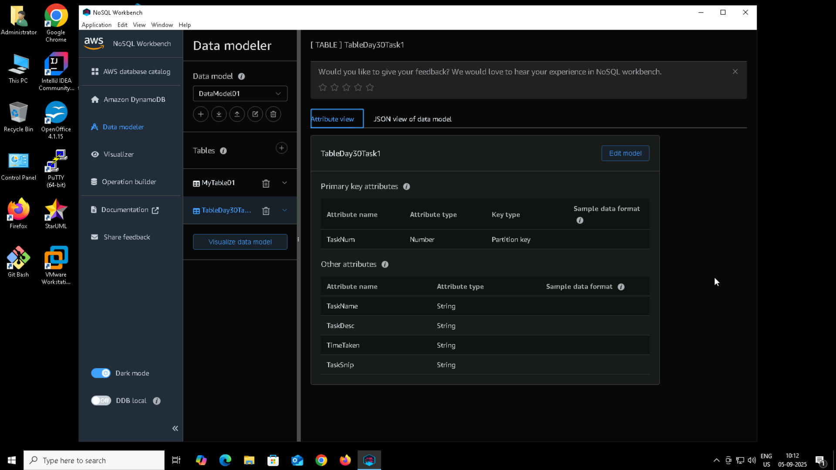

Q2. Use all CRUD operations   
Ans. CRUD operations are –

Create iteam  
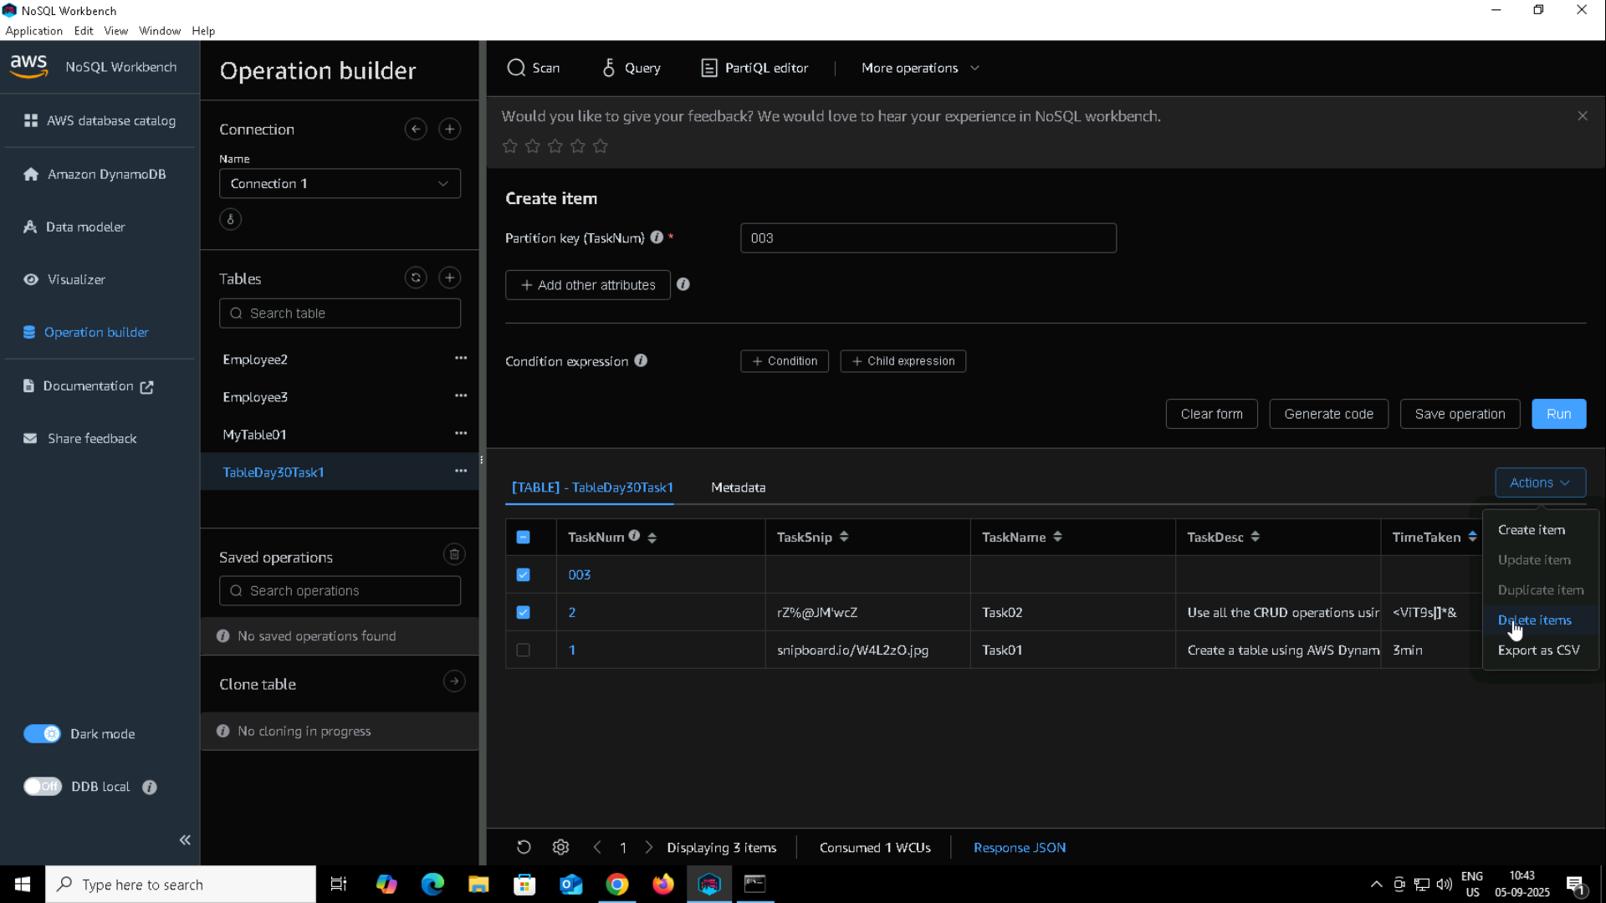

Read item  
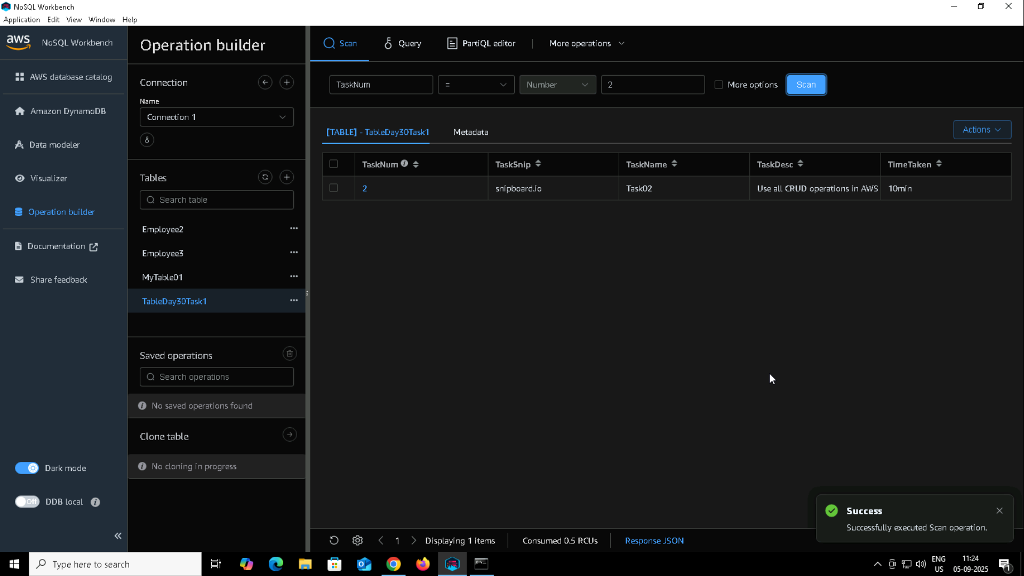

Update item  
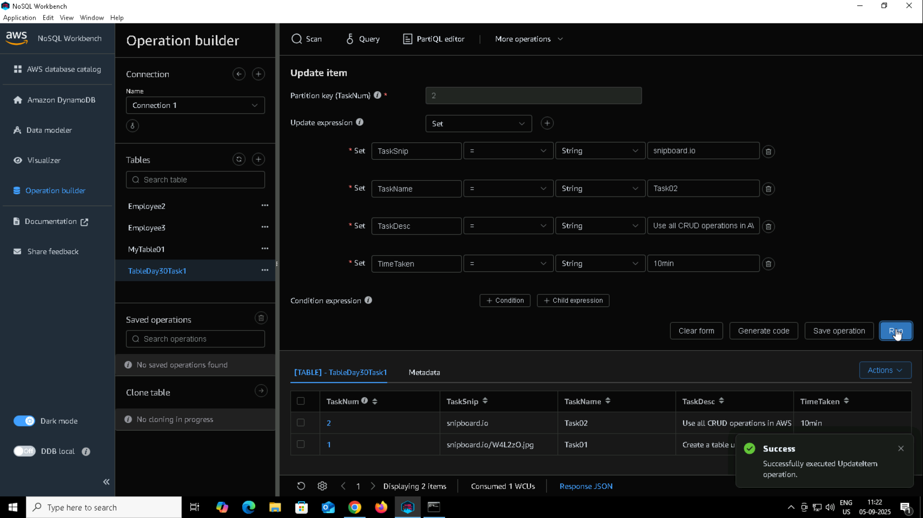

Delete item  
